

Foundations of Programming

Assignment No.: 01
- PROBLEM STATEMENT:
Write a program in C to check whether a given year is a Leap Year

OBJECTIVE:

- To understand the use of conditional statements in C programming.
- To implement logical conditions for solving real-world problems.
- To develop problem-solving skills using decision control structures.

THEORY:
- Theory for conditional statements with syntax (if, if-else, if-else ladder) are used in C programming
ANSWER:
In C programming, conditional statements (also known as decision-making statements) allow a program to execute different blocks of code based on whether a specific condition is true or false.
In C, a condition is considered true if it evaluates to any non-zero value, and false if it evaluates to zero.
I. The Simple if Statement
The if statement is the most basic decision-making structure. It is used to execute a block of code only if the specified condition evaluates to true. If the condition is false, the code block is skipped entirely.
II. The if-else Statement
The if-else statement handles two possible paths. It executes one block of code if the condition is true and a different block of code if the condition is false.
III. The if-else-if Ladder
The if-else-if ladder is used when you need to check multiple conditions sequentially. The program checks conditions from the top down. As soon as it finds a true condition, it executes the associated block and ignores the rest. If none of the conditions are true, the final else block (if present) is executed.
- Theory for a Leap Year - year that contains 366 days instead of the usual 365 days.
I. The Astronomical Theory
A standard calendar year has 365 days, but the Earth actually takes approximately 365.2422 days to orbit the Sun.
- If we ignored this fractional day, our calendar would drift out of sync with the seasons (about 24 days every 100 years).
- The Solution: We add one extra day (February 29th) almost every four years to keep the calendar aligned with the Earth's orbit.
II. The Rules (The Logic)
Determining a leap year is slightly more complex than just "every 4 years." The Gregorian calendar uses three criteria to ensure precision:
- Rule 1: If a year is evenly divisible by 4, it is a leap year...
- Rule 2: ...UNLESS it is evenly divisible by 100. Then it is NOT a leap year...
- Rule 3: ...UNLESS it is evenly divisible by 400. Then it IS a leap year.
- Algorithm
Step-by-Step Algorithm
This approach checks conditions one by one (nested logic), which corresponds to an if-else-if ladder in C.
- Step 1: Start the program.
- Step 2: Declare an integer variable (e.g., year).
- Step 3: Input the value of year from the user.
- Step 4: Check if year is divisible by 400 (year % 400 == 0).
  - If True: Print "Leap Year" and go to Step 8.
  - If False: Go to Step 5.
- Step 5: Check if year is divisible by 100 (year % 100 == 0).
  - If True: Print "Not a Leap Year" (because it failed the 400 check but hit the 100 check) and go to Step 8.
  - If False: Go to Step 6.
- Step 6: Check if year is divisible by 4 (year % 4 == 0).
  - If True: Print "Leap Year" and go to Step 8.
  - If False: Go to Step 7.
- Step 7: If all previous checks failed, Print "Not a Leap Year".
- Step 8: Stop/End the program.

PLATFORM: Linux
Code:
#include <stdio.h>

int main()
{
int year;
printf("Enter a year: ");
scanf("%d", &year);
if ((year % 4 == 0 && year % 100 != 0) || (year % 400 == 0)) {
printf("%d is a Leap Year.\n", year);
} else {
printf("%d is NOT a Leap Year.\n", year);
}

return 0;
}
INPUT and OUTPUT
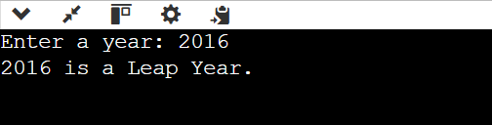
CONCLUSION: Thus, the program successfully checks whether a given year is a Leap Year using conditional statements in C.

Problem Statement 2:
“Write a C program to accept the marks of 5 subjects from the user. The program should verify if the student has passed or failed and assign a grade based on the following rules:"

ALGORITHM:
1.Start
2.Input: Read marks for 5 subjects (s1, s2, s3, s4, s5).
3.Fail Check: Check if any single subject is less than 40.
4.If s1 < 40 OR s2 < 40 OR s3 < 40 ... then set Result to FAIL.
5.Calculate: If the student passed all subjects:
Calculate Total = s1 + s2 + s3 + s4 + s5
Calculate Percentage = Total / 5
6.Classify: Assign a class based on the Percentage:
Percentage >= 75: Distinction
Percentage >= 60: First Class
Percentage >= 50: Second Class
Percentage >= 40: Pass Class
7.Output: Print the Total, Percentage, and final Result/Class.
8.Stop

Code:
#include <stdio.h>

int main() {
float s1, s2, s3, s4, s5;
float total, percentage;
printf("Enter marks for 5 subjects:\n");
scanf("%f %f %f %f %f", &s1, &s2, &s3, &s4, &s5);
total = s1 + s2 + s3 + s4 + s5;
percentage = total / 5.0;
if (s1 < 40 || s2 < 40 || s3 < 40 || s4 < 40 || s5 < 40) {
printf("Percentage: %.2f%%\n", percentage);
printf("Result: FAIL (Scored less than 40 in one or more subjects)\n");
}
else {
printf("Total Marks: %.2f\n", total);
printf("Percentage: %.2f%%\n", percentage);
if (percentage >= 75) {
printf("Class: Distinction\n");
}
else if (percentage >= 60) {
printf("Class: First Class\n");
}
else if (percentage >= 50) {
printf("Class: Second Class\n");
}
else {
printf("Class: Pass Class\n");
}
}
return 0;
}
INPUT and OUTPUT:
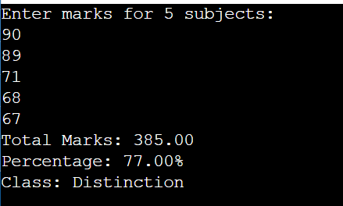\
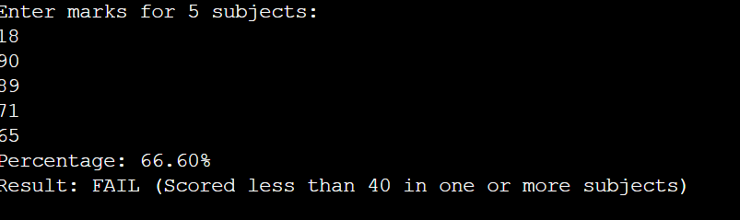

PROBLEM STATEMENT 3:
"Write a C program to input three sides of a triangle. First, check if the triangle is VALID. If it is valid, determine whether the triangle is Equilateral, Isosceles, or Scalene."

Algorithm:
- Start
- Input: Read three sides (a, b, c).
- Check Validity:
- IF (a + b > c) AND (b + c > a) AND (a + c > b) are all True:
  - Then Check Type:
    - IF a == b AND b == c then Print "Equilateral".
    - ELSE IF a == b OR b == c OR a == c then Print "Isosceles".
    - ELSE then Print "Scalene".
- ELSE (If validity fails):
  - Print "Invalid Triangle (Sum of two sides must be greater than the third)".
- Stop

CODE:
#include <stdio.h>
int main() {
int side1, side2, side3;
printf("Enter three sides of the triangle: ");
scanf("%d %d %d", &side1, &side2, &side3);
if ((side1 + side2 > side3) && (side2 + side3 > side1) && (side1 + side3 > side2)) {
if (side1 == side2 && side2 == side3) {
printf("The triangle is Equilateral.\n");
}

else if (side1 == side2 || side2 == side3 || side1 == side3) {
printf("The triangle is Isosceles.\n");
}
else {
printf("The triangle is Scalene.\n");
}
}
else {
printf("The triangle is INVALID.\n");
}
return 0;
}
INPUT and OUTPUT:
